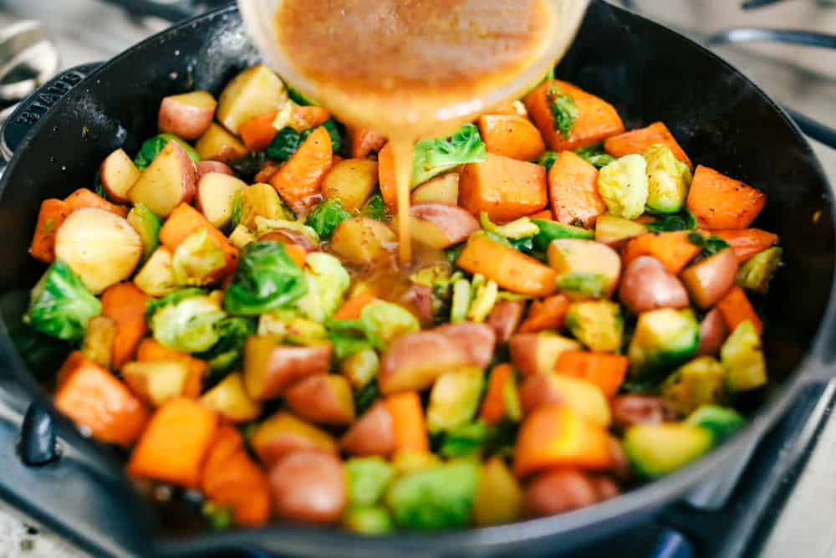
Maple Dijon Vegetables

Prep Time 10 min Cook Time 20 min
6 Servings

Ingredients
1/4 cup Dijon mustard
1/3 cup maple syrup
1 Tbsp apple cider vinegar

Directions
- In a large skillet add 2 tablespoons olive oil. Add vegetables. Sauté until almost fork tender.
- In a small bowl, whisk together the ingredients. Warm and pour on top of the vegetables.

